**Memo**

**TO:** Tyler Lown, WRI327, Oregon Institute of Technology

**FROM:** Ethan Dunzer

**DATE:** May 20, 2021

**SUBJECT:** Usability Report: Technical Description and Technical Instructions

This memo is constructed to give informative results of the Technical Description and Technical Instructions through heuristic analysis. The topics of said Technical documents are "Controlling the Auditing Process" and "User management polices" which detail the current projected security and computer systems auditing processes and policies. The information below will be included strengths, weaknesses, comments, and filled out heuristic checklists of what should be in each document.

**Technical Description**

The technical description is titled "Control Auditing Process" and covers the process in which the projected company should carry out their control audits of their IT infrastructure.

*Introduction, Background, and Components:*

Over the introduction and background section have a lot of useful information that would be great for a document detailing what a technical audit is, but in this circumstance, I think it’s not necessary. When introducing a document like this it needs to be made very clear what the document is about and why it is needed. Although it was stated that the "logical access control management" will be used that information would only be relevant to someone who knows exactly what that would entail. Furthermore, in the graphic "Logical Access Control" is defined as 3 elements but those elements are not defined until after the introduction. This being said it is very useful information, but I think it doesn't belong in the introduction and background. Instead, the introduction needs to give the reader information about what is covered in this document only and what they are supposed to do with said information.

It would also be good to explicitly state who the audience for the document is, and what the scenario is that this document will be used in.

*Process:*

The audit planning section which describes the processes of the audit is very well put together and does a great job of explaining and detailed what each topic is. I do think the Figure 1 graphic (Figure-1) should have gone here along with that background description that was given. Additionally, I think there should be more description on how each process will be implemented in this particular business context. Most of the writing seems to be overall summary about the topic, or process and not the particular instance that will be used in.

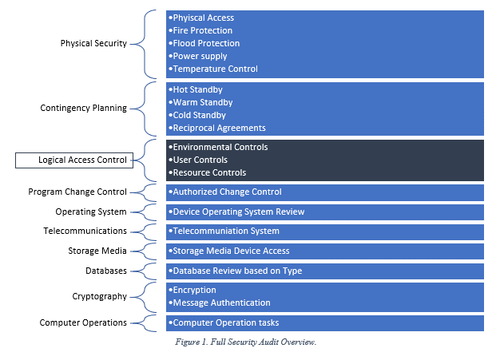

*Figure-1 [Lown, Tyler (2021). Control Auditing Process.]*

*Conclusion:*

This conclusion is very well written and actually could be used for the introduction. It does a much better job with summarizes what exactly is going to take place and how it will affect who uses it. The emphasis on the different focuses does a great job in wrapping up all that was shown in the document and help the reader remember the important parts that were detailed.

*Document Design:*

As stated, before the design and layout of this document is very well done. There are great contrasting font sizes and definition that make it very easy to find the main points and topics that are detailed. One potential problem would be the lack of space between the introduction section and the main processes. As said above the figure one graphic should really be somewhere in the main body of the document and not in the intro section which makes it too compact. Since this document is a process, I would have liked to see a more defined numbered layout that details exactly what comes first and then last (Figure-2), but I don't think it’s a major problem that would affect the document.

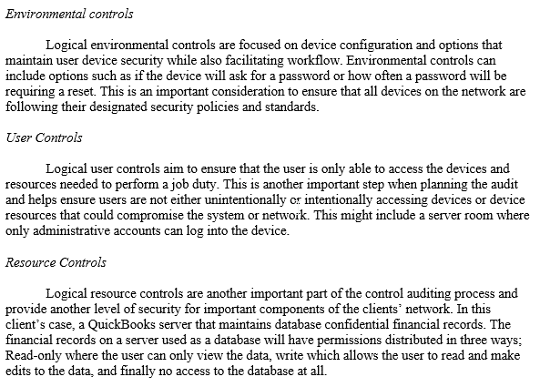

*Figure-2 [Lown, Tyler (2021). Control Auditing Process.]*

*Graphics:*

The two graphics in this document are chosen very well and do a great job illustrating the processes that are outlined in the document. As stated, above figure one does need to be moved but is still a great resource for the reader. If possible, I think added simple graphics that show the resources that will be used might be beneficial, for example a network diagram or the relationships between user and network.

*Prose/Language:*

The language is fairly close to what I would call a expert user. This would definitely be used by someone who knows about reforming network audits and what most networks entail. With that being said I do still think that some terms could have been defined more and given more information about. Even though this seems to be an expert user that doesn't mean the document wouldn't be used as an example in a meeting about what has to be done to perform a network audit.

**Technical Instructions**

The technical instructions are titled "User management polices" and covers the in-depth policies and procedures that should be taken into account and completed for staff members.

*Title and Introduction:*

I immediately realized that this document has a much better introduction and summary on what is happening or going to happen in the document. The summary section in particular was a great way to give the reader a quick precise of reading to explain what this document is for. The actual intro has great information about why this document is needed and what will come from its information. Frankly the only part that I think needs to be there much like the technical description document is its relation to the specific business and why, when, and how the procedures and policies were put in place.

The introduction also does a great job of detailing who the document is for and what is expected of their knowledge in order to complete these processes going as far as to give a graphic that details what each police will need.

*Step-by-Step Instructions:*

These are very well done and though out thoroughly. Everything is done very well in relation to the sub process title and makes complete sense when you go through it. Also, great job in catching potential problem areas where the user would need assistance and need to call or request further assistance.

As far as formatting goes, I do think it would be helpful and go even further on the number convention and number each sub process instruction so that users can reference it when using the document.

*Conclusion:*

Your conclusion definitely finishes the document off well and relates to the main topic of the document very well. It might be good to add something that would signal what exactly this document completed as far as the policies, I know you stated why they are important but not why this particular document is. Something to think about.

Also, very smart in detailing that this document has other partner documents that give further details about other polices, this is great to have in the conclusion since that is where most users would think of going to the next document. However, I do think it might be good to mention this in the introduction as well so that if the user wants a specific policy document, they don't have to go to the bottom of this one.

*Document Design:*

The overall structure is almost perfect. All information is in the correct numbering and format but there are some parts that I think could use some polishing. First spacing. There needs to be much more spacing between each policy topic in order to be able to find it more quickly. Secondly the numbering needs to change from 3.01.1 (Figure-2) to 3.1.1 in order to stay consistent and also to make it easier for the reader to find. Third the main starting title of the policy needs to stand out more from the sub process titles (Figure-4). Maybe make the sub process title not bold and instead italics so that when looking for the main processes bold is easily indefinable.



*Figure-3 [Lown, Tyler (2021). User management policies.]*

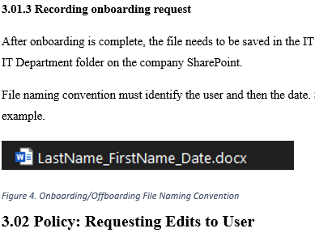

*Figure-4 [Lown, Tyler (2021). User management policies.]*

*Graphics:*

Like I said earlier, the graphics are well executed in this document and even do a better job than the technical description document in not only giving the reader illustrated diagrams but also reference graphics. There are several sub processes that could use another graphic to help orient the user on where they are supposed to be but overall, I think this was great.

*Prose/Language:*

Again, the language is fairly close to what I would call an expert user, but it makes more sense in this document since it was detailed in the introduction what kind of user is expected. Saying this I think everything makes sense to that user and there is no need for the definitions and explanations that might have been needed in the previous document.

**Conclusion**

As far as all the documents go, I think you have a very well-done assignment that only needs some polishing to make sure you check all the boxes that are required in the heuristics. I think re-evaluating your papers audience might be very important and will change the way you right the introductions. It seems for the Technical description that you were thinking in a broad sense and instead should be more focused on a particular instance. This would enable you to customize the work and identify the scope more clearly, along with targeting the audience more clearly.

**References**

Lown, Tyler (2021). Control Auditing Process.

Lown, Tyler (2021). User management policies.

